10.1" 4-wire resistive screen
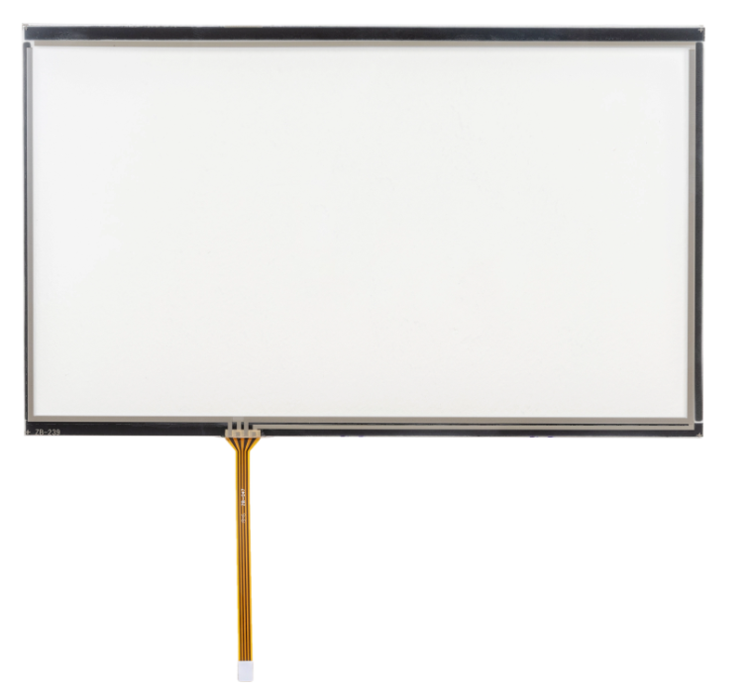
Specification
1.ITOFilm：Anti-glare&anti-NewtonRing；
2.Tail Type：FPC By Golden Plated
3.Transparency：≥75%
4.Linearity：≤1.5%.；
5.Surface Hardness：3H
6.Terminal resistance：
(1)TOP：150-500Q
(2)Botton：300-700Q
7.Operation Temperature：-20°C~+70°C.
8.Storage Temperature：-30°C~+80°C.
9.All materials in the drawing comply with the ROHS

Dimensional drawings
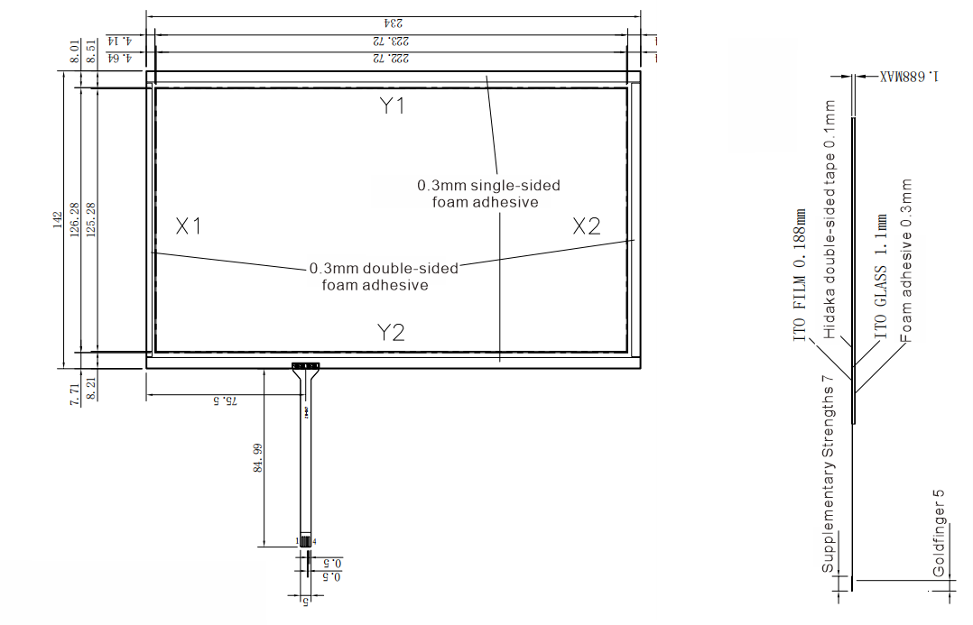
Product Logic Diagram

