Industrial Grade Isolated USB Converter
USB TO RS232/485/TTL
Stable Transmission | Multiple Devices Applicable | Multi-OS Compatible
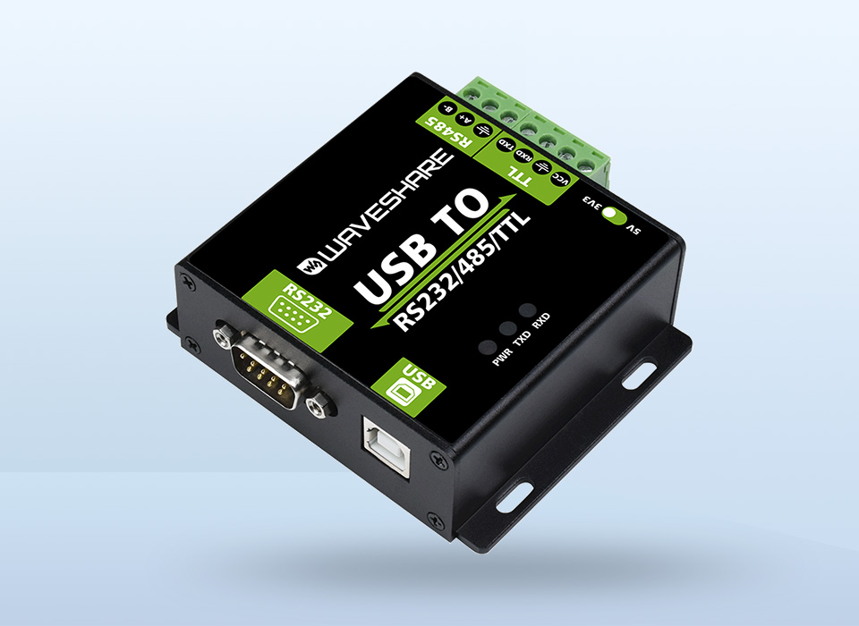
Features At A Glance
- Adopt original FT232RL or CH343G inside, fast communicating, stable and reliable, better compatibility

- Onboard unibody power supply isolation, provides stable isolated voltage, needs no extra power supply for the isolated terminal

- Onboard unibody digital isolation, allows signal isolation, high reliability, strong anti-interference, low power consumption
- Onboard TVS (Transient Voltage Suppressor), effectively suppress surge voltage and transient spike voltage in the circuit, lightningproof & ESD protection

- Onboard self-recovery fuse and protection diodes, ensures the current/voltage stable outputs, provides over-current/over-voltage proof, improves shock resistance

- Fully automatic transceiver circuit with no delay, ensures the USB port communicates with different interfaces fastly and stably, without interfering each other

- Onboard TTL serial 3.3V/5V voltage translator, config the TTL level via switch

- Aluminium alloy enclosure with sand blasting and anodic oxidation, CNC process opening, solid and durable

- 3 LEDs for indicating the power and transceiver status
- High quality USB-B and RS232 connectors, smoothly plug/pull
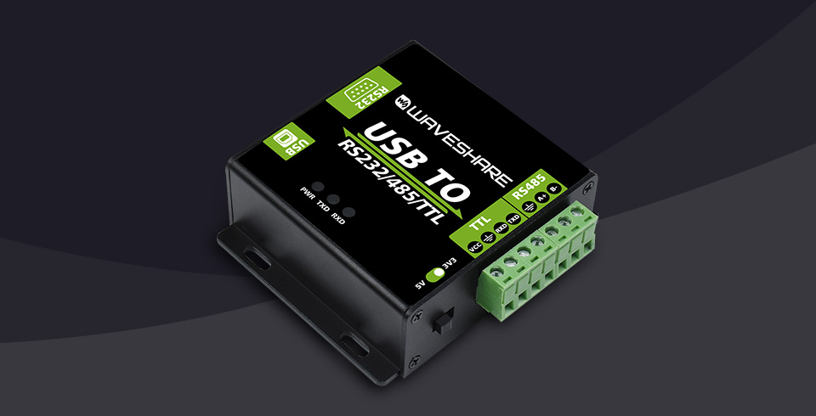
Version Option
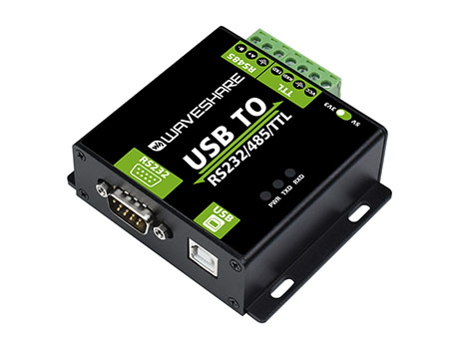
FT232RL Version

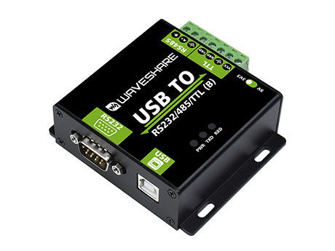
CH343G Version
Specifications
PRODUCT TYPE | Industrial grade digital isolated converter
USB | Operating voltage | 5V
 | Connector | USB-B
 | Protection | 200mA self-recovery fuse, isolated output
RS232 | Connector | DB9 male
 | Protection | TVS diode, surge protection & ESD protection
 | Transmission mode | Point-to-point
 | Baud rate | FT232RL: 300bps ~ 921600 bps  CH343G: up to 600000 bps (not full band)
RS485 | Connector | Screw terminal
 | Pins | A+/B-/GND
 | Direction control | Hardware automatically discriminates and controls the direction of data transmission
 | Protection | 600W lightningproof and surge-suppress, 15KV ESD protection (reserved 120R balancing resistor solder pads
 | Transmission mode | Point-to-multipoints (up to 32 nodes, it is recommended to use repeaters for 16 nodes or more)
 | Baud rate | FT232RL: 300bps ~ 2 Mbps  CH343G: up to 2 Mbps (not full band)
TTL (UART) | Operating voltage | 3.3V / 5V
 | Connector | Screw terminal
 | Pins | TXD, RXD, GND, 5V
 | Protection | clamp protection diode, over-voltage/negative-voltage proof, shock resistance
 | Transmission mode | Point-to-point
 | Baud rate | FT232RL: 300 bps ~ 2 Mbps  CH343G: up to 2 Mbps (not full band)
INDICATORS | PWR | Red power indicator, light up when there is USB connection and voltage is detected
 | TXD | Green TX indicator, light up when the USB port sends data
 | RXD | Blue RX indicator, light up when the device ports send data back
OPERATING ENVIRONMENT | Temperature | -15℃ ~ 70℃
 | Humidity | 5%RH ~ 95%RH
OPERATING SYSTEM | Mac, Linux, Android, Windows 11 / 10 / 8.1 / 8 / 7

Original Industrial Grade Chip
Onboard Original FT232 Or CH343 Chip
Fast Communication, Stable & Reliable, Better Compatibility
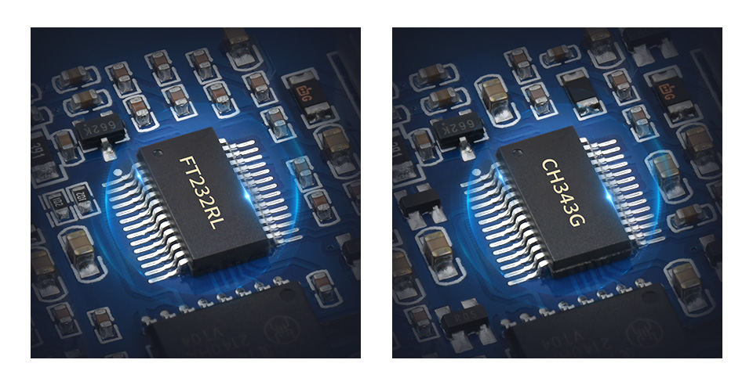

Safer Isolated Design
- Onboard unibody power supply isolation, provides stable isolated voltage, needs no extra power supply for the isolated terminal
- Onboard unibody digital isolation, allows signal isolation, high reliability, strong anti-interference, low power consumption
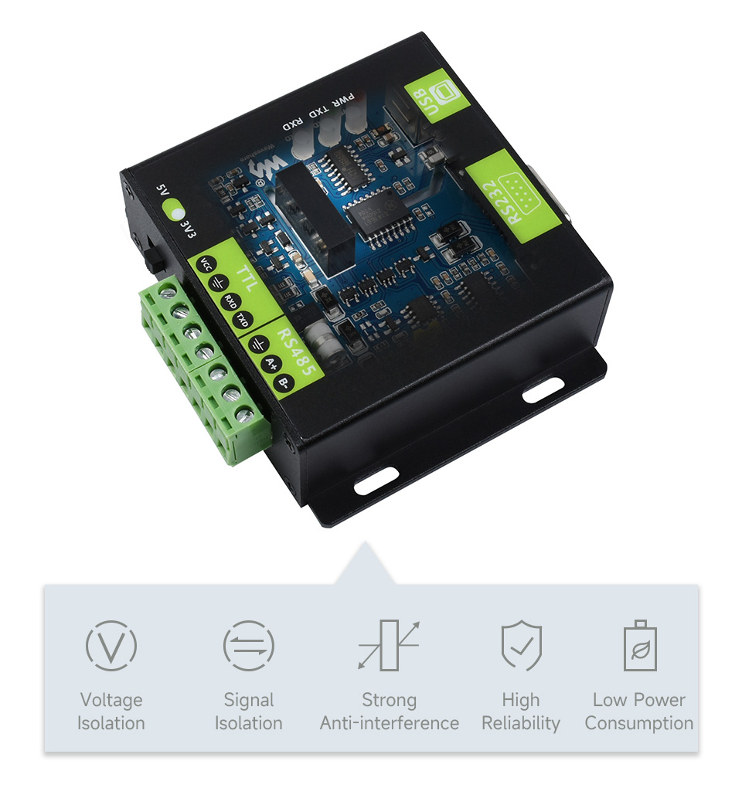

Multi-Protocol & Multi-Type Conversion
USB TO RS232, RS485 Or TTL(UART)
RS232, RS485 Or TTL(UART) TO USB
* only one of the RS232, RS485, and TTL can be converted to USB at the same time; And RS232, RS485, and TTL cannot be converted between each other

Multiple Protection, Safe And Stable
Onboard TVS (Transient Voltage Suppressor), effectively suppress surge voltage and transient spike voltage in the circuit, lightning proof & ESD protection. Onboard self-recovery fuse and protection diodes, ensures the current/voltage stable outputs, provides over-current/over-voltage proof, improves shock resistance.
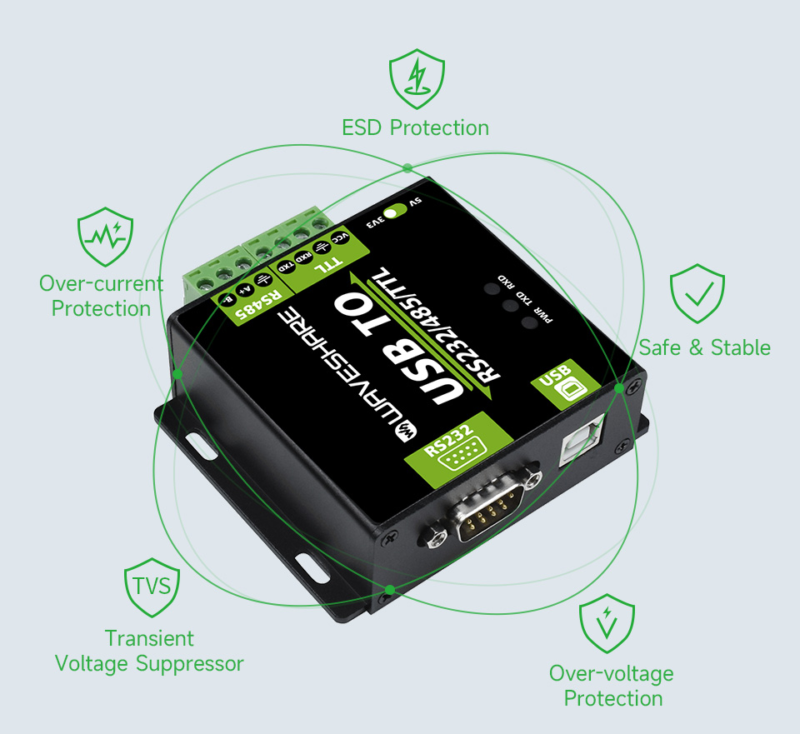

Multi System Support
Supports Mac, Linux, Android, Windows 11 / 10 / 8.1 / 8 / 7, Etc.
Pinout Definition
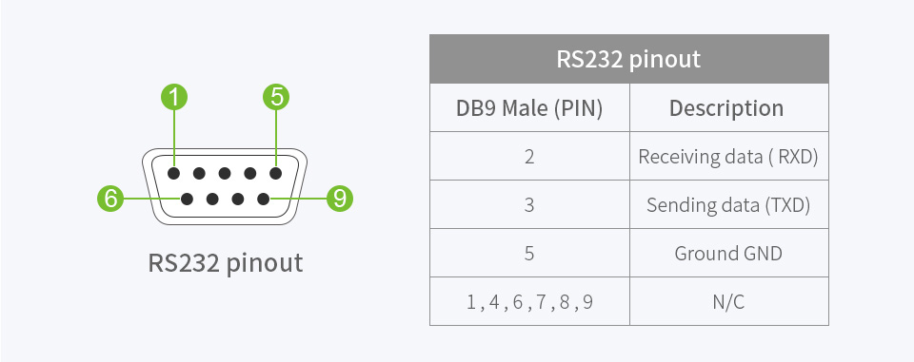

Working Status Indicators
Onboard 3 LEDs For Indicating The Power And Transceiver Status
Aluminium Alloy Enclosure
Aluminium Alloy Enclosure With Sand Blasting And Anodic Oxidation
Solid And Durable, Fashion And Good Hand Feeling
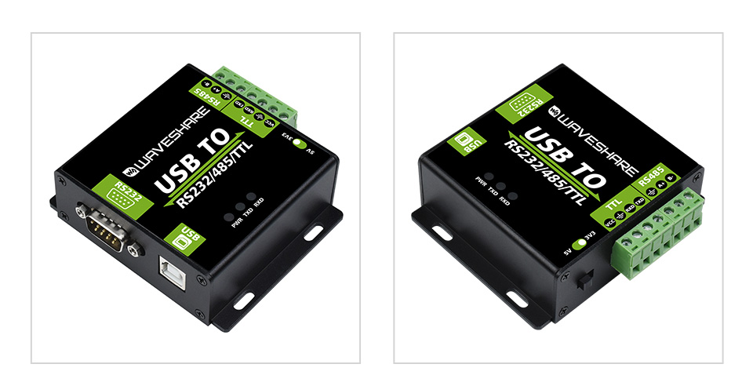

Interface Introduction
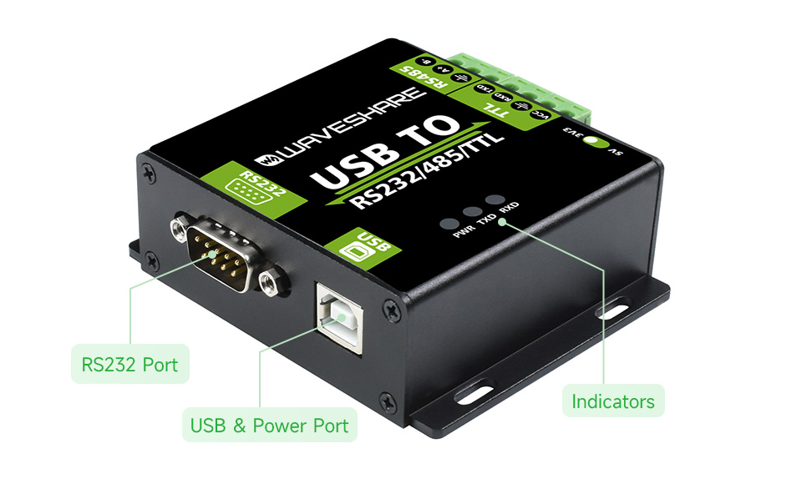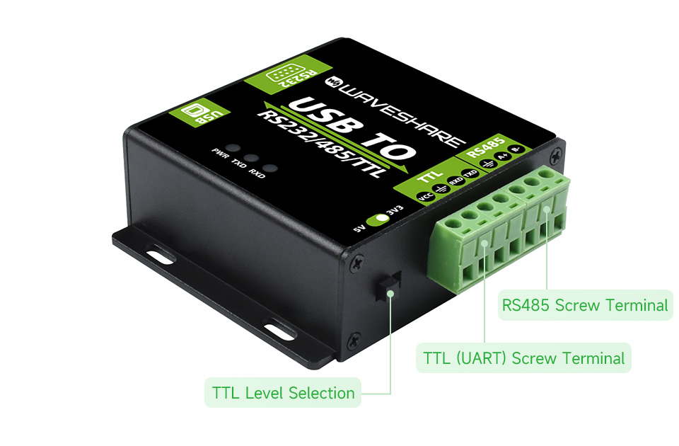

Outline Dimensions
