14mm NU40A14T-1 Waterproof Distance Measuring Transmission Ultrasonic Sensor Probe
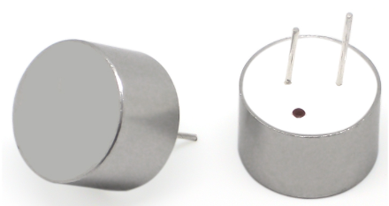

Product Description
Ultrasonic transducers are sensors that convert ultrasonic signals into other energy signals (usually electrical). This product vibrates a mechanical wave with a frequency of 40KHz. The vibration frequency of this product is 40KHz mechanical wave. It has the characteristics of high frequency, short wavelength, small bypass phenomenon, especially good directionality, and the ability to become ray and directional propagation and other characteristics.

Applications
Ultrasonic distance measurement, back-up radar, etc.
Security and alarm systems
Robot design and research
Ultrasonic level measurement

Product Parameter
Product Category: Waterproof
Product Category: Transmitter (transceiver split)
Center Frequency：40.0KHz±2%
Bandwidth: 1KHz
Transmit sensitivity (reference value): 110dBMin.(40KHz10Vp-p/30cm0dB=10V/Pa)
Receiving sensitivity (reference value): -82dBMin.(40KHz10Vp-p/30cm0dB=10V/Pa)
Static capacitance: 1900pF±20%
Maximum input voltage (pulse): 120Vp-p
Test distance (reference value): 5m
Direction angle (reference value): 75°±15°(-6dB)
Resolution (reference value): 10mm
Weight: 1g
Case material: aluminum shell
Color: Aluminum natural color
Operating temperature: -20°C~+80°C
Storage temperature: -40°C~+85°C

Dimensional drawings
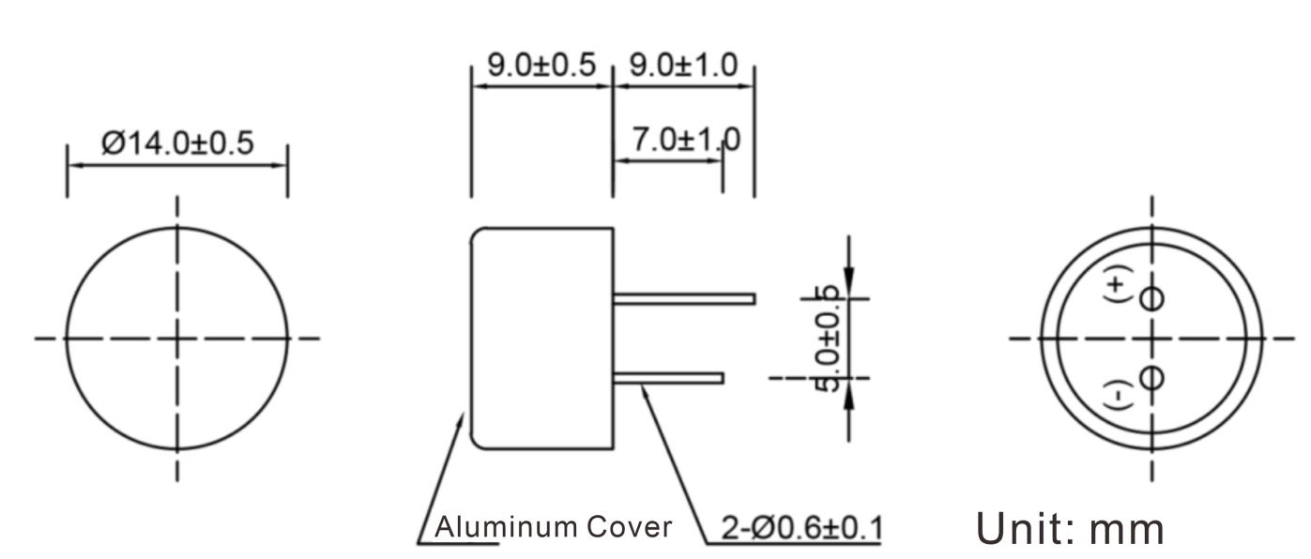

Line Graph
