5V Bluetooth TPA3110 Digital Stereo Audio Power Amplifier Board Bluetooth 4.2 15W

AH211
Introduction of products
The board adopts the typical circuit of TPA3110, using a single power supply with anti-reverse connection, it is very convenient to use a common adapter and switching power supply for its power supply, most of the capacitive resistive devices using standardized SMD process, simple and stable. Bluetooth audio receiver module for the design of specialized interfaces, built-in 5V voltage regulator circuit, can easily DIY Bluetooth speaker. Output power is 15WX2(@16V), the board can be connected to 8 ohm, 4 ohm speakers.
Supply voltage:10-25VDC
Power supply current: recommended 2A, or above
Output power:15WX2(@16V)

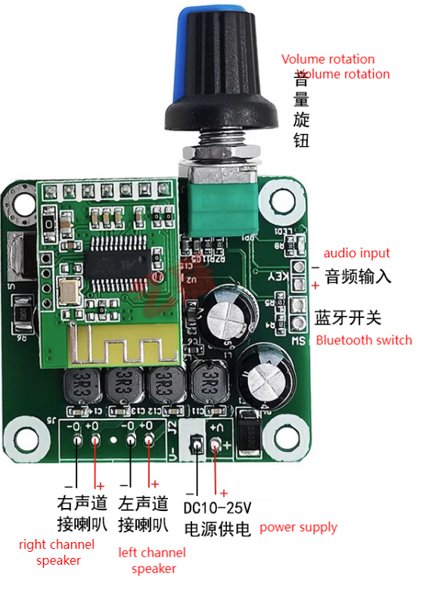
Description of power supply：
When using a universal adapter with switching power supply, can be connected directly to the positive and negative poles of the power supply. If you use a linear transformer power supply, recommended AC voltage of 9-12V (up to 15V AC), the power of 20-30W linear transformer, you need to add a rectifier filter board (the store has matching sale), the display chart is as follows:
