LED Gyro DIY Welding Kit Rotating Lantern（without battery)
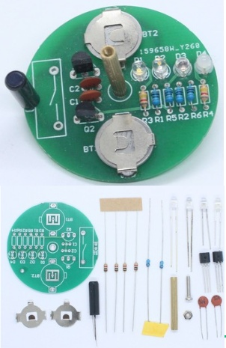

Product Function
When rotating the gyro, the circuit is automatically activated and a dashed combination pattern of 4 colors appears.

Installation Precautions
All components should be installed close to the surface of the circuit board, and should pay attention to the polarity direction of the light-emitting diode, transistor and battery. The LEDs of different colors can be installed in a staggered manner according to your preference, without affecting the normal operation of the circuit. The circuit board S 1 is designed with two switch positions, which can be installed with 18010 or 28020 type vibration switch, the kit only comes with one, the nut and screws are mounted under the circuit board, the total height of the gyroscope can be changed by adjusting the nut position appropriately, the knurled copper post is mounted on the top of the circuit board, together with the nut, the circuit board will be clamped together.

Schematic diagram
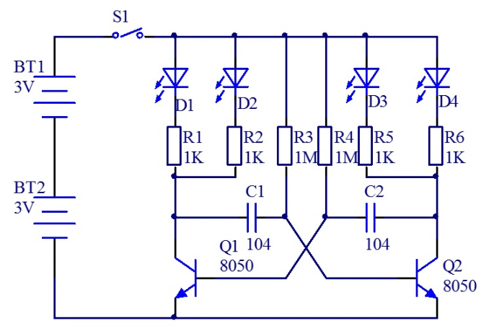
Circuit Principle
When the battery is loaded, the vibration switch S1 is off, so the circuit does not work. When the gyro is rotated, due to the centrifugal effect, the vibration switch S1 is turned on and the circuit works. The working principle of the polyharmonic oscillator is that when the power is turned on, the two transistors Q1 and Q2 will have to compete to lead first, but due to the differences in the components, only a certain tube leads first. Then the circuit of the two transistors will take turns to conduct and cut off, two light-emitting diodes will continue to cycle light. When rotating the gyroscope, the bright LED will appear a straight line, because the lights are staggered, at the same time every two lights are alternately bright, so there are multiple dotted line shape pattern.

Component Distribution
