XY-CD60L Solar Battery Charger Controller Module DC6-60V Charging Discharge Control Low Voltage Current Protection Board
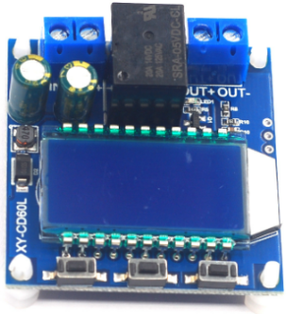
Product Description
The module has two modes: charging mode IN and discharging mode OUT, suitable for 6~60V lithium batteries, the module itself is not a charger, it is used for charging and discharging protection and charging and discharging control, users need to prepare their own battery charger.

Product Parameter
Suitable for 6~60V storage battery, lithium battery.

Mode Description
Charging mode IN
By setting the upper limit voltage UP, lower limit voltage dn; when the battery voltage ≤ lower limit voltage dn, the relay conducts, and the charger starts to charge the battery; when the battery voltage ≥ upper limit voltage UP, the relay disconnects, and completes an automatic charging; the relay conducts, and the IN blinks to indicate that it is charging.
Charging mode: for battery charging control
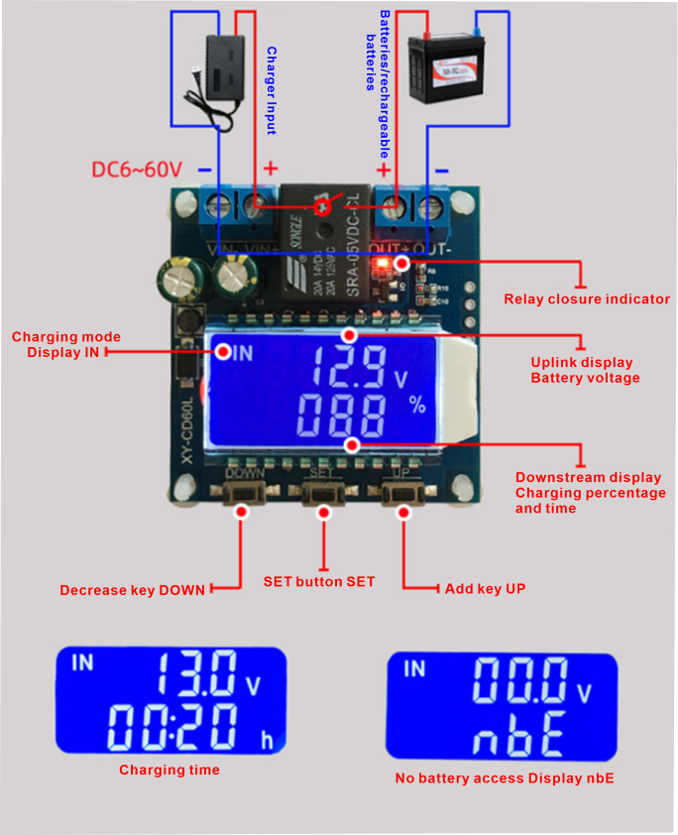
Battery charging control wiring diagram
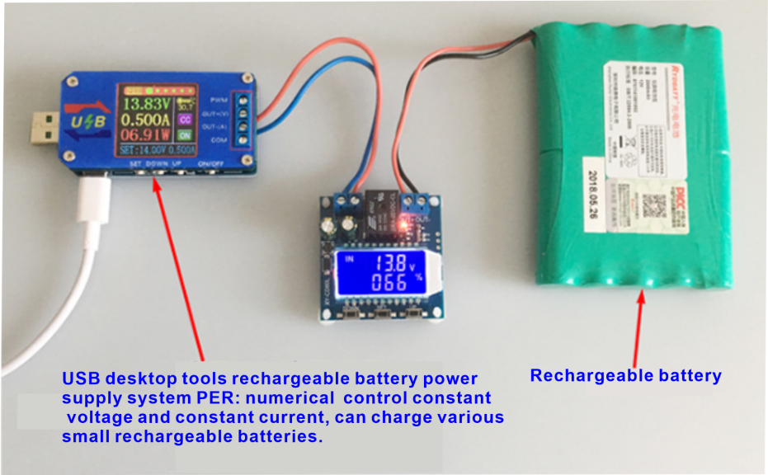
Discharge mode OUT
By setting the upper limit voltage UP, lower limit voltage dn; when the battery voltage ≥ the upper limit voltage UP, the relay conducts and starts discharging; when the battery voltage ≤ the lower limit voltage dn, the relay disconnects and completes the function of automatic discharging; the relay conducts and the OUT blinks to indicate that it is discharging.
Discharge mode: for battery under-voltage protection/low battery loss protection
Effective prolongation of battery life/DC voltage protector
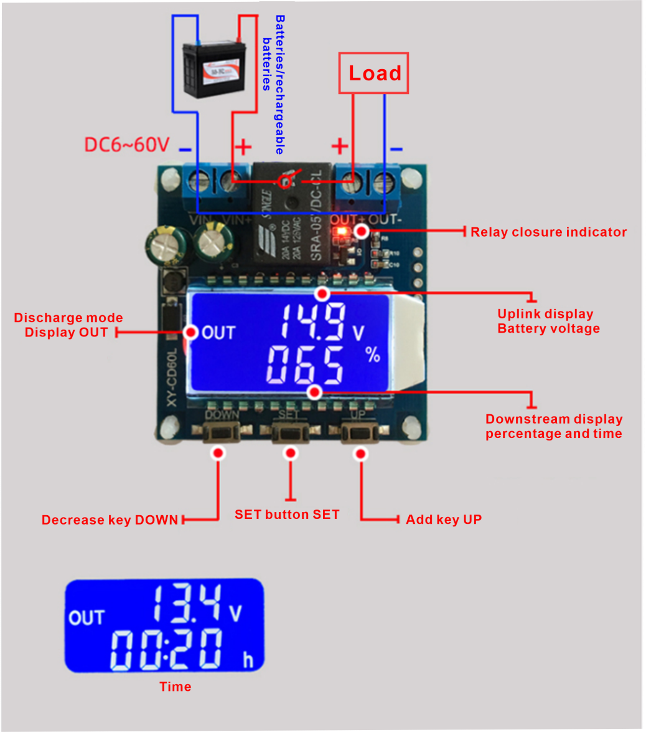
Battery undervoltage protection wiring diagram
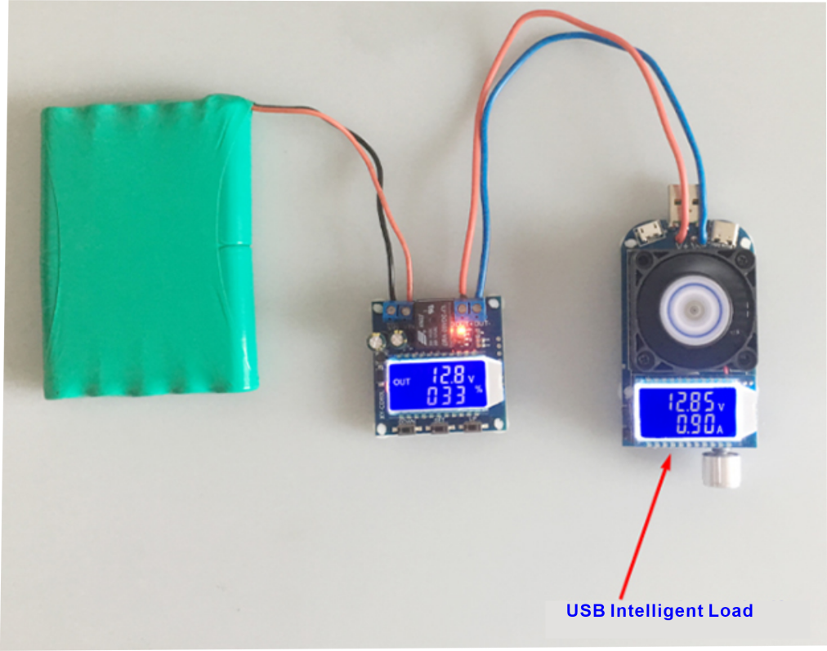
Note: This product is a simple voltage controller, is through the relay to turn on and off the output.
It only plays the role of switching, can not change voltage.

Function
1, Calculation of voltage percentage: battery voltage/(upper limit voltage-lower limit voltage)
2, Key function:
UP button: short press to switch the display % and time, long press for 5 seconds to switch mode, charge mode: IN, discharge mode: OUT
SET button: short press to view the currently set parameters; long press SET button to enter the parameter setting interface, set UP: upper voltage limit, dn: lower voltage limit; OP: on-time, dOP: delayed on-time (0-999 seconds), discharge mode, under the FOP: forced on-time (0-10 seconds)
DOWN button: short press to turn off/on the relay enable (emergency stop function) after turning off, the LCD will show OFF and the relay will be disconnected.
Long press DOWN button to set the status of LCD backlight L-P: OFF backlight is always on.
ON: the backlight will go out automatically after 5-10 minutes; after it goes out, press any key to wake up.
Parameter setting
a. Press and hold the SET key to enter the parameter setting interface;
b. After entering the parameter setting interface, press the SET key briefly to switch the parameter setting; c. After selecting the parameter, you can set it by UP/DOWN key, which supports short press and long press;
d. If you want to set other parameters, repeat steps b) and c);
e. After all parameters are set, press and hold the SET key to exit and save.
Parameter setting in charging mode
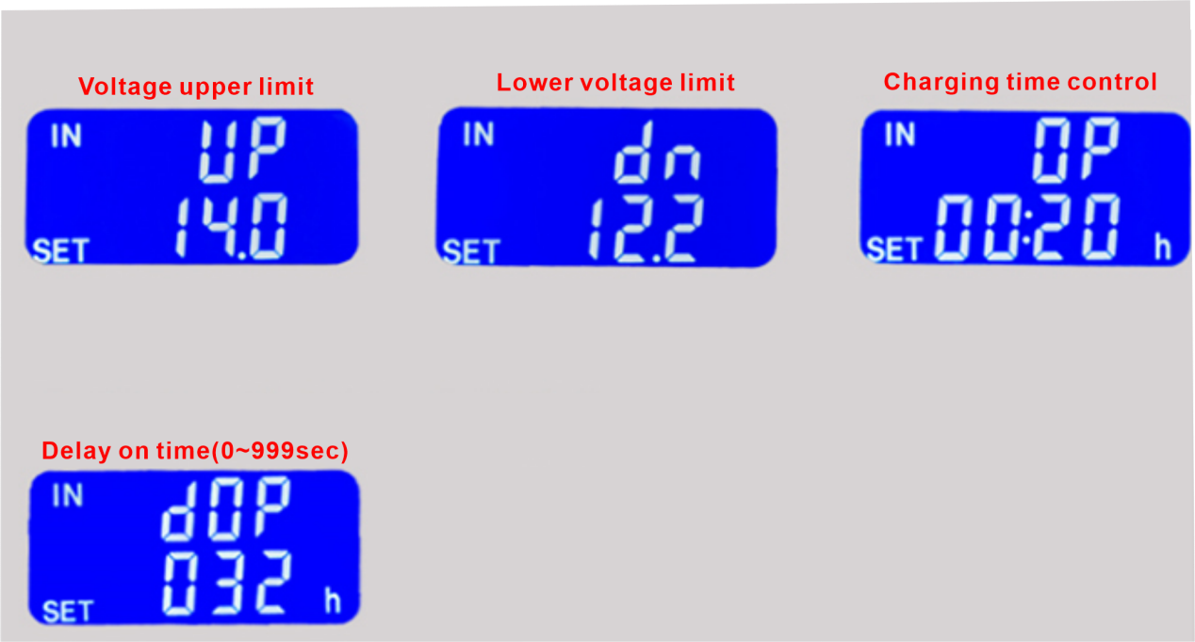
Parameter setting in discharge mode
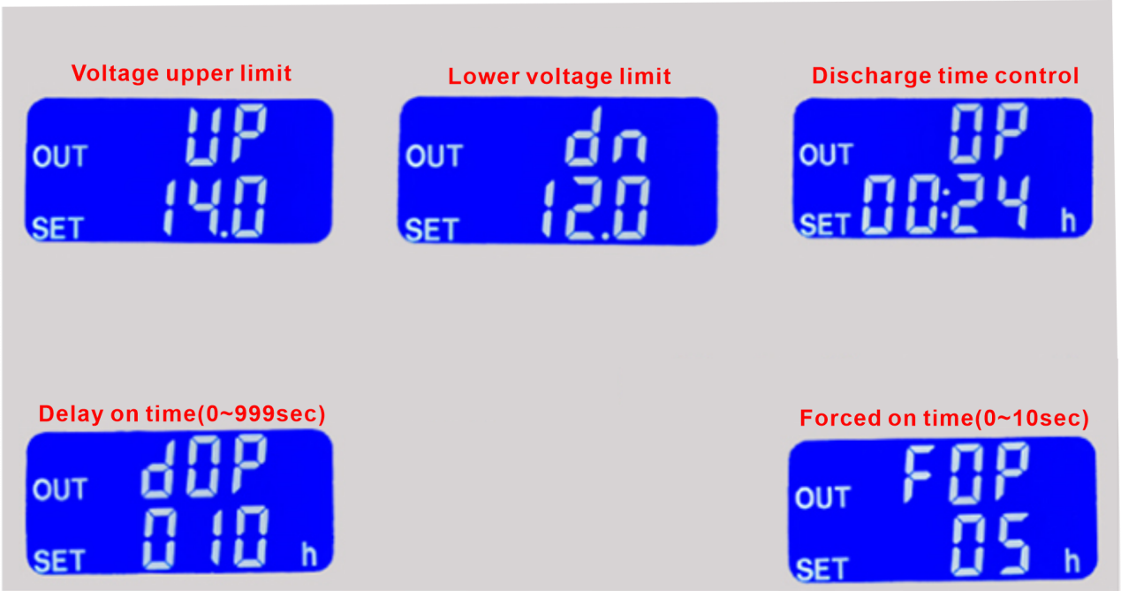
Charge/discharge time control function
When the setting time parameter OP is non-zero, the charging/discharging time control will be activated; when the relay conducts to open the charging/discharging once, the timing will start; when the timing is completed, the relay will be disconnected automatically to complete the charging/discharging process; if the timing is completed, the charging/discharging time control function will be shut down automatically and display HER to remind the user. In charging mode, the detected voltage is <lower limit voltage dn or in discharging mode, the detected voltage is >upper limit voltage UP, it will automatically turn off the charging time control function and flash H:ER to remind the user that the time parameter setting is unreasonable; press any key to stop flashing.
When charging/discharging time control is not turned on, the product will record the complete time once, when entering the time display interface, the charging time will be displayed with flashing; and then it will be cleared when exiting the time display interface or when the next charging is turned on (the relay is on).
Parameter automatic detection
When setting parameters and exiting, if the lower voltage limit dn≥upper voltage limit, the system will flash "ERR" as a reminder.
Delayed on-off function dOP(0~999sec)
Interval time between completing one charge/discharge and turning on again; Discharge conduction forced start time FOP(0~10S).
After meeting the conditions of relay conduction, the relay is forced on (0~10S), and the battery voltage is detected again; this function is mainly for the discharge function, some test loads will be instantly pulled down to the lower voltage limit at the moment of conduction, which will be triggered by mistake and lead to the relay disconnecting, and the normal discharging process can not be carried out.

Product dimension
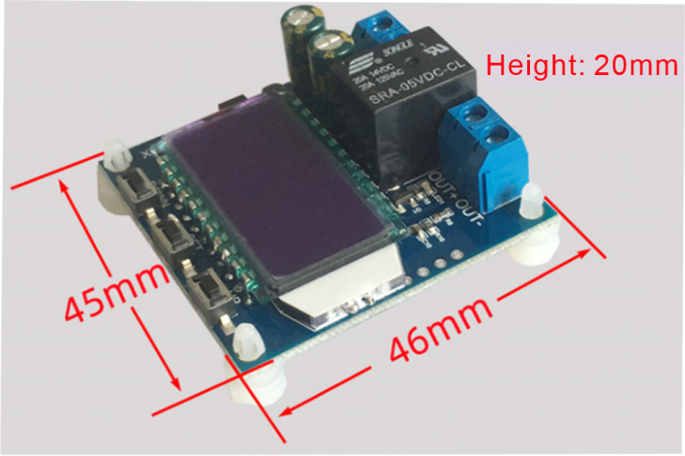
Note: Manual measurement has error, please prevail in kind.

FQA
Q: For how many V level use? This product is suitable for how many V voltage?
A: This section is suitable for a minimum of 6V, up to 60V voltage range, the maximum expenditure level of 48V, because the 48V battery is fully charged 60V or so, and then higher on the burn, if your battery is higher than 48V, please choose another model.
Q: The relay pops after powering up!
A: This is due to your charging current is too large or battery capacity is too small caused by a power-up immediately reached the upper voltage limit, the relay disconnect, disconnect, the voltage and quickly drop to the lower voltage limit, and start charging, cycle after cycle, at this time you have to reduce the charging current to work, usually charging current is the battery capacity of one-tenth of a 1-1.5, such as 20AH battery charging current is generally in the 2-3A or so! Note that high current charging will cause the battery to heat up and accelerate aging, bulging and even explosion!
Q: What kind of control? Can it automatically cycle charging? Can it charge while using? Can it limit current?
A: This is the voltage control, for example, set the lower voltage limit 12.0V, the upper voltage limit 14.5V, voltage charging to 14.5V this value on the power off, the voltage is reduced to 12.0V relay closure to start charging; can be used while charging, the voltage control mode only play a shutdown and open, can not limit current, charging current depends entirely on your charger!

